**MINI PROJECT REPORT**

**On**

**ONLINE CLOTH STORE**

**Submitted by**

MUDIT MANGAL

(171500194)

KUNAL GOYAL

(171500171)

MAYANK GARG

(171500185)

Department of Computer Engineering & Applications

**Institute of Engineering & Technology**



**GLA University**

**Mathura- 281406, INDIA**

**2019**



**Department of Computer Engineering and Applications**

**GLA University, Mathura**

**17 km. Stone NH#2, Mathura-Delhi Road, P.O. – Chaumuha,**

**Mathura – 281406**

**Declaration**

I hereby declare that the work which is being presented in the Mini Project “**ONLINE CLOTH STORE**”**,** in fulfilment of the requirements for Summer Training viva voce, is an authentic record of my own work carried under the supervision of **Mr. Pankaj Kapoor.**

**Name of Candidates:**

Mudit Mangal(171500194)

Kunal Goyal(171500171)

Mayank Garg(171500185)

**Course:** B.tech (CSE)

**Year:** 3rd Year

**Semester:** V Semester

# **Acknowledgement**

I thank the almighty for giving me the courage and perseverance in completing the project.

This project itself is acknowledgement for all those people who have given me their heartfelt cooperation in making this project a grand success. I extend my sincere thanks to Mr Pankaj Kapoor, Associate Professor at GLA University for providing valuable guidance at every stage of this project work. I am profoundly grateful towards the unmatched services rendered by him. Lat but not Least, I would like to express to deep sense of gratitude and earnest thanks to my dear parents for their moral support and heartful cooperation in doing main project.

# **Abstract**

The main objective of Online Cloth Store is to automate the existing manual system with the help of advance computerized software so that valuable data can be stored for longer period with easy accessing and manipulation of the same.

The registered user can access the account with valid credentials. User can surf the cloths according to categories.

This website will provide the list of different menu list with different categories. User can select any item from store and can order for it by using wallet Payment.

Contents

**Acknowledgement** i

**Abstract** ii

**Introduction** 1

1.1 Motivation 1

1.2 Overview 1

1.3 Objective 2

1.4 How it benefits a cloth store 3

1.5 How it benefits a customer 3

**Technology Used** 5

2.1 HTML 5

2.2 CSS 6

2.3 JavaScript 7

2.4 BootStrap 4 7

2.4 jQuery 8

2.5 PHP 9

**Software Requirement Analysis** 10

3.1 Problem Statement 10

3.2 Modules and their Functionalities 10

3.2.1 Frond-End (Main Website) 10

3.3 Software Requirement 11

3.3.1 Brackets 11

3.3.2 WAMP 11

**Software Design** 13

4.1. Use case Diagram 13

4.3 Structure of Databases 15

4.3.1 Category Table Structure 15

4.3.2 User Table Structure 15

4.3.3 Product Table Structure 16

4.3.4 Cart Table Structure 17

4.3.5 Orders Table Structure 17

**Implementation** 16

5.1 Storing the files in Main Directory 16

5.2 Login Page 17

5.3 Signup Page 19

5.4 Main Page 21

5.5 Checkout Page 24

5.6 Enter details Page 25

**Validation** 27

27

6.1 Signup Page Validation 27

6.2 Sign in Page Validation 29

**Conclusion** 31

**Future Scope** 32

**References/Bibliography** 33

**Chapter 1**

# **Introduction**

## 1.1 Motivation

The main objective of online cloth store is to automate the existing manual system with the help of advance computerized software so, that valuable data can be stored for longer period with easy accessing and manipulation of the same. Usually People have to go to shop and order the cloths and they have to wait in queue for a long time to pay bills and get their cloths. But with the help of this you just have to follow a very simple process to order your stuffs. And you need not to wait in the long queue.

## 1.2 Overview

The main aim of this project Online Cloth Store is to provide fast services to the customers. Usually People have to go to shops and order the appreals and they have to wait in queue for a long time to get their stuff. But with the help of this you just have to follow a very simple process to order your stuffs. And you need not to wait in the long queue. The main advantage of an online ordering system is that it greatly simplifies the ordering process for both the customer and the store. When the customer visits the ordering web page, they are presented with an interactive and up-to-date menu, complete with all available options and adjusting prices based on the selected options. After making a selection, the item is then added to their order, which the customer can review the details at any time before checking out. This provides instant visual confirmation of what was selected. This system also greatly lightens the load on the store’s end, as the entire process of taking orders is automated. Once an order is placed on the web page, it is entered into the database

Online Cloth Store Introduction

and then retrieved, in pretty much real-time, by a web-based application on the store’s end.

Time Saving: Our Online Cloth Store is developed with a primary aim of saving time. The customer can order the appreals and it is also efficient for store workers because this system takes lesser time as compared to phone based or manually based system.

No Complication: Major complication part for Online Cloth Store is adding a product or managing products section. In our Online Cloth Store, no complicated part is involved in managing sections; we have taken immense care in this section and nullified all complications which make this system accurate and unique.

Cost Effective: It's cheaper. You don't have to purchase multiple copies of software to install on multiple computers. Multiple copies often require you to pay multiple licensing fees, but since you aren't actually purchasing any software with an online system, that's not a concern.

Security: Online systems are just as secure. Most Online Cloth Store websites allow you to create multiple user accounts with various levels of access. Your data is stored on secure, protected servers that feature firewalls and other online security programs.

## 1.3 Objective

Online Cloth Store is the system where customers order their favourite cloths and receive them in the home without any delay as these will be directly delivered and collect what they ordered without waiting for a turn or waiting time. This system aims to accelerate customer orders and customer order system used by employees to accept customer order.

Online Cloth Store Introduction

The purpose of the system is to develop a simple Online Cloth Store and implement it, which later will be used for a web-based application.

The proposed “Online Cloth Store” is economically feasible because:

1. The system requires very fewer time factors as compared to manual system.
2. The system will provide fast and efficient automated environment instead of slow and error prone manual system, thus reducing both time and manpower spent in running the system.
3. The system will have GUI interface and very less user training is required to learn it.

## 1.4 How it benefits a cloth store

Online Cloth Store saves the shop’s time by avoiding the cloth orders in the shop that has to be done manually. By making the ordering process fully automated, it increases the cost effectiveness and productivity of the store with a less man power. In addition, it keeps you one step ahead of your competitors who don’t serve online.

Online Cloth Store even helps a casual shop and provides an additional revenue source. It allows a shop owner to easily update the online menu, items etc and helps to stay in touch with the customers by offering discounts and targeted promotions. With a simplified management process, online ordering system makes it easy to handle multiple shops from centralized application.

## 1.5 How it benefits a customer

Now a days people are getting busy with their work, making the shop online even saves customers time undoubtedly. Is allow them to order cloths online by creating a flexible ordering platform and serve them in time. The customer can select the different appreals from the online menu on the store website and can order

Online Cloth Store Introduction

accordingly as per their interest. In fact, they can place order the orders within their budget by adding or removing the items as per the cost variations.

This Online Cloth Store is useful for the store as well customer because Online Cloth Store save the time of the shop’s workers as well of the customers and as saves the manpower.

**Chapter 2**

# **Technology Used**

## 2.1 HTML

Hypertext Mark-up Language (HTML) is the standard [markup language](https://en.wikipedia.org/wiki/Markup_language) for documents designed to be displayed in a [web browser](https://en.wikipedia.org/wiki/Web_browser). It can be assisted by technologies such as [Cascading Style Sheets](https://en.wikipedia.org/wiki/Cascading_Style_Sheets) (CSS) and [scripting languages](https://en.wikipedia.org/wiki/Scripting_language) such as [JavaScript](https://en.wikipedia.org/wiki/JavaScript).

[HTML elements](https://en.wikipedia.org/wiki/HTML_element) are the building blocks of HTML pages. With HTML constructs, [images](https://en.wikipedia.org/wiki/HTML_element#Images_and_objects) and other objects such as [interactive forms](https://en.wikipedia.org/wiki/Fieldset) may be embedded into the rendered page. HTML provides a means to create [structured documents](https://en.wikipedia.org/wiki/Structured_document) by denoting structural [semantics](https://en.wikipedia.org/wiki/Semantics) for text such as headings, paragraphs, lists, [links](https://en.wikipedia.org/wiki/Hyperlink), quotes and other items. HTML elements are delineated by *tags*, written using [angle brackets](https://en.wikipedia.org/wiki/Bracket#Angle_brackets). Tags such as <**img** /> and <**input** /> directly introduce content into the page. So basically, we used HTML to design our website in which we different element and different attribute so that it’s looks attractive so some of the elements are listed here:

1. <html></html>
2. <head></head>
3. <body></body>

And we follow the basic syntax approach to design our page that is :

<html><head>

<title> College Management System</title>

<link rel=” stylesheet” href=” ../CSS/style.css”>

</head><body> ………… ……… ……... </body></html

Online Cloth Store Technology Used

## 2.2 CSS

Cascading Style Sheets (CSS) is a [style sheet language](https://en.wikipedia.org/wiki/Style_sheet_language) used for describing the [presentation](https://en.wikipedia.org/wiki/Presentation_semantics) of a document written in a [mark-up language](https://en.wikipedia.org/wiki/Markup_language) like [HTML](https://en.wikipedia.org/wiki/HTML). CSS is designed to enable the separation of presentation and content, including [layout](https://en.wikipedia.org/wiki/Page_layout), [colours](https://en.wikipedia.org/wiki/Color), and [fonts](https://en.wikipedia.org/wiki/Typeface). This separation can improve content [accessibility](https://en.wikipedia.org/wiki/Accessibility), provide more flexibility and control in the specification of presentation characteristics, enable multiple [web pages](https://en.wikipedia.org/wiki/Web_page) to share formatting by specifying the relevant CSS in a separate .css file, and reduce complexity and repetition in the structural content. CSS also has rules for alternate formatting if the content is accessed on a [mobile device](https://en.wikipedia.org/wiki/Mobile_device). The CSS specifications are maintained by the [World Wide Web Consortium](https://en.wikipedia.org/wiki/World_Wide_Web_Consortium) (W3C). CSS provide the HTML element styling so that element looks attractive so we different type of properties in CSS to style the element some of the examples are listed below and basic syntax follow:

.class-name or #id-name

{ width: 100%;

height: 80px;

position: absolute;

background-color: #1f1f1f;

top: 0;

opacity: 0.9;

border-bottom: 3px solid white;

z-index: 8;

border-top-right-radius: 10px;

border-bottom-right-radius: 10px;

border-top: 1px solid white;

border-right: 3px solid white;}

Online Cloth Store Technology Used

## 2.3 JavaScript

JS, is a [high-level](https://en.wikipedia.org/wiki/High-level_programming_language), [interpreted](https://en.wikipedia.org/wiki/Interpreted_language) [scripting language](https://en.wikipedia.org/wiki/Scripting_language). Alongside [HTML](https://en.wikipedia.org/wiki/HTML) and [CSS](https://en.wikipedia.org/wiki/CSS), JavaScript is one of the core technologies of the [World Wide Web](https://en.wikipedia.org/wiki/World_Wide_Web). JavaScript enables interactive [web pages](https://en.wikipedia.org/wiki/Web_page) and is an essential part of [web applications](https://en.wikipedia.org/wiki/Web_application). As a multi-paradigm language, JavaScript supports [event-driven](https://en.wikipedia.org/wiki/Event-driven_programming), [functional](https://en.wikipedia.org/wiki/Functional_programming), and [imperative](https://en.wikipedia.org/wiki/Imperative_programming) [programming styles](https://en.wikipedia.org/wiki/Programming_paradigm). It has [APIs](https://en.wikipedia.org/wiki/Application_programming_interface) for working with text, [arrays](https://en.wikipedia.org/wiki/Array_data_type), dates, [regular expressions](https://en.wikipedia.org/wiki/Regular_expression), and the [DOM](https://en.wikipedia.org/wiki/Document_Object_Model). Initially only implemented [client-side](https://en.wikipedia.org/wiki/Client-side) in web browsers, JavaScript engines are now embedded in many other types of host software, including [server-side](https://en.wikipedia.org/wiki/Server-side) in web servers and databases, and in non-web programs such as word processors and [PDF](https://en.wikipedia.org/wiki/Portable_Document_Format) software, and in runtime environments that make JavaScript available for writing mobile and desktop applications, including desktop widgets. Java script used for validation purpose so in our project we use Java Script to define the major functionality for specific element. When we use Java Script in our project, we use the <script></script> tag to define the function of an element.

## 2.4 BootStrap 4

Bootstrap 4 is the newest version of Bootstrap, which is the most popular HTML, CSS, and JavaScript framework for developing responsive, mobile-first websites. Bootstrap 4 is completely free to download and use!. Bootstrap is a powerful front-end framework for faster and easier web development. It includes HTML and CSS based design templates for creating common user interface components like forms, buttons, navigations, dropdowns, alerts, modals, tabs, accordions, carousels, tooltips, and so on.

Bootstrap gives you ability to create flexible and responsive web layouts with much less efforts.

Online Cloth Store Technology Used

Bootstrap was originally created by a designer and a developer at Twitter in mid-2010. Before being an open-sourced framework, Bootstrap was known as Twitter Blueprint.

## 2.4 jQuery

jQuery is an open source JavaScript library that simplifies the interactions between an HTML/CSS document, or more precisely the Document Object Model (DOM), and JavaScript.

jQuery is a fast and concise JavaScript library created by John Resig in 2006. jQuery simplifies HTML document traversing, event handling, animating, and Ajax interactions for Rapid Web Development.

Elaborating the terms, jQuery simplifies HTML document traversing and manipulation, browser event handling, DOM animations, Ajax interactions, and cross-browser JavaScript development.

All jQuery methods are inside a document ready event to prevent any jQuery code from running before the document is finished loading (is ready). It is friendly, which is to say it provides helpful ways to avoid conflicts with other JavaScript libraries.

Basic syntax for any jQuery function is:

$(selector).action()

1. A $ sign is to define/access jQuery
2. A (selector) is to “query (or find)” HTML elements in html page
3. A jQuery action() is the action to be performed on the selected element(s)

Example:

$(document).ready(function(){

      $("button").click(function(){

           $(".gfg").hide(); };) });

Online Cloth Store Technology Used

## 2.5 PHP

PHP: Hypertext Pre-processor (or simply PHP) is a [general-purpose programming language](https://en.wikipedia.org/wiki/General-purpose_programming_language) originally designed for [web development](https://en.wikipedia.org/wiki/Web_development). PHP originally stood for Personal Home Page*.* PHP code may be executed with a [command line interface](https://en.wikipedia.org/wiki/Command-line_interface) (CLI), embedded into [HTML](https://en.wikipedia.org/wiki/HTML) code, or used in combination with various [web template systems](https://en.wikipedia.org/wiki/Web_template_system), web [content management systems](https://en.wikipedia.org/wiki/Content_management_system), and [web frameworks](https://en.wikipedia.org/wiki/Web_framework). PHP code is usually processed by a PHP [interpreter](https://en.wikipedia.org/wiki/Interpreter_(computing)) implemented as a [module](https://en.wikipedia.org/wiki/Plugin_(computing)) in a web server or as a [Common Gateway Interface](https://en.wikipedia.org/wiki/Common_Gateway_Interface) (CGI) executable. PHP used as backend programming as well as to connect to the database so PHP code will start in <?php?> tag in which all the PHP code done.

Syntax:

<? php

……………………………

…………………………….

?>

**Chapter 3**

# **Software Requirement Analysis**

## 3.1 Problem Statement

The main objective of Online Cloth Store is to automate the existing manual system with the help of advance computerized software so that valuable data can be stored for longer period with easy accessing and manipulation of the same. Online Cloth Store is to provide fast services to their customers. Usually People have to go to shop and order the appreals and they have to wait in queue for a long time to get the orders. But with the help of this you just have to follow a very simple process to order your stuffs. And you need not to wait in the long queue.

## Modules and their Functionalities

### Frond-End (Main Website)

Through this front-end customer can login and can perform the operations for which they are authorized respectively.

Functionalities provided to the customers are defined below.

* 1. Register:User need to register first with basic registration details and need to create a valid login id and password.
  2. Login:User need to login using their valid login credentials in order to access the web application.
  3. View Items:All the items will be displayed to the user at once with description and cost.

Online Cloth Store Software Requirement

4 Add to Cart:Single or multiple item can be added to cart by selecting quantity.

1. Order and Pay:Order can be placed of selected items by using a dummy card
2. Checkout: You can check out with the items that you have selected and at your home the order will be delivered.

## 3.3 Software Requirement

### 3.3.1 Brackets

Brackets is a [source code editor](https://en.wikipedia.org/wiki/Source_code_editor) with a primary focus on [web development](https://en.wikipedia.org/wiki/Web_development). Created by [Adobe Systems](https://en.wikipedia.org/wiki/Adobe_Systems), it is [free and open-source software](https://en.wikipedia.org/wiki/Free_and_open-source_software) licensed under the [MIT License](https://en.wikipedia.org/wiki/MIT_License), and is currently maintained on [GitHub](https://en.wikipedia.org/wiki/GitHub) by Adobe and other open-source developers. It is written in [JavaScript](https://en.wikipedia.org/wiki/JavaScript), [HTML](https://en.wikipedia.org/wiki/HTML) and [CSS](https://en.wikipedia.org/wiki/CSS). Brackets is [cross-platform](https://en.wikipedia.org/wiki/Cross-platform), available for [macOS](https://en.wikipedia.org/wiki/MacOS), [Windows](https://en.wikipedia.org/wiki/Microsoft_Windows), and most [Linux distributions](https://en.wikipedia.org/wiki/Linux_distribution). The main purpose of brackets is its live [HTML](https://en.wikipedia.org/wiki/HTML), [CSS](https://en.wikipedia.org/wiki/Cascading_Style_Sheets) and [JavaScript](https://en.wikipedia.org/wiki/JavaScript) editing functionality Brackets Quick edit enables inline editing of CSS, Color Property, and JavaScript elements for developers. This built-in feature can be applied to multiple functions or properties simultaneously and all updates are applied directly to the file associated with the changed elements. Live Preview, this feature also pushes code edits instantly to the [browser](https://en.wikipedia.org/wiki/Web_browser) to present an updated webpage as the developers modify the code.

### 3.3.2 WAMP

It Stands for "Windows, Apache, MySQL, and PHP." WAMP is a variation of [LAMP](https://techterms.com/definition/lamp) for Windows systems and is often installed as a [software](https://techterms.com/definition/software) bundle (Apache, MySQL, and PHP). It is often used for [web development](https://techterms.com/definition/web_development) and internal testing, but may also be used to serve live websites.

Online Cloth Store Software Requirement

The most important part of the WAMP package is [Apache](https://techterms.com/definition/apache) (or "Apache HTTP Server") which is used run the [web server](https://techterms.com/definition/web_server) within Windows. By running a local Apache web server on a Windows machine, a web developer can test [webpages](https://techterms.com/definition/webpage) in a [web browser](https://techterms.com/definition/web_browser) without publishing them live on the Internet.

WAMP also includes [MySQL](https://techterms.com/definition/mysql) and [PHP](https://techterms.com/definition/php), which are two of the most common technologies used for creating [dynamic websites](https://techterms.com/definition/dynamicwebsite). MySQL is a high-speed database, while PHP is a scripting language that can be used to access data from the database. By installing these two components locally, a developer can build and test a dynamic website before publishing it to a public web server.

**Chapter 4**

# **Software Design**

## 4.1. Use case Diagram

A **use case diagram** at its simplest is a representation of a user's interaction with the system that shows the relationship between the user and the different **use** cases in which the user is involved.

**Customer**

Fig 4.1- Use Case Diagram

Online Cloth Store Software Design

4.2. Dataflow Diagrams

Data Flow diagrams show the flow of data from external entities into the system,

and from one process to another within the system.

* 1. Level - 0 Diagram: The level 0 diagram provides a conceptual view of the process and its surrounding input, output and data stores. It is called context level Data flow diagram also.

**User**

**Login System**

**User**

**Logout System**

**Select**

**Items**

**Check Out**

**System**

Fig. 4.2 Level Zero Dataflow Diagram (DFD)

Online Cloth Store Software Design

## 4.3 Structure of Databases

### 4.3.1 Category Table Structure

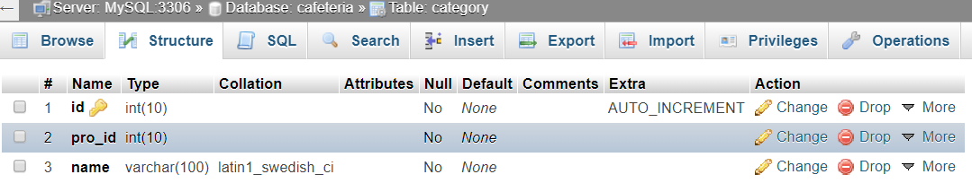

Fig 4.3- Category Table Structure

### 4.3.2 User Table Structure

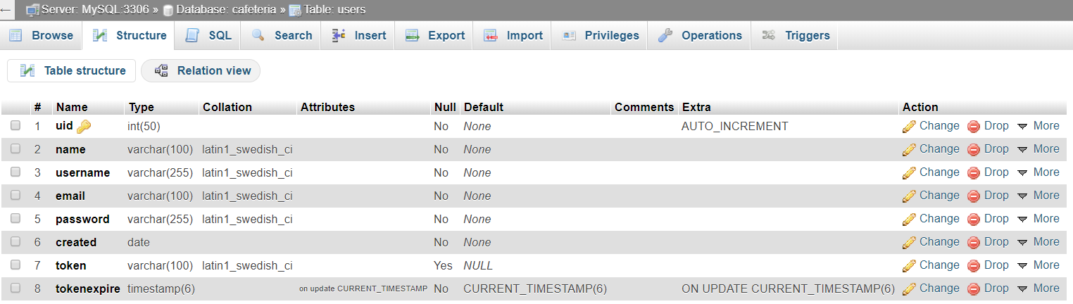

Fig 4.4- User Table Structure

Online Cloth Store Software Design

### 4.3.3 Product Table Structure

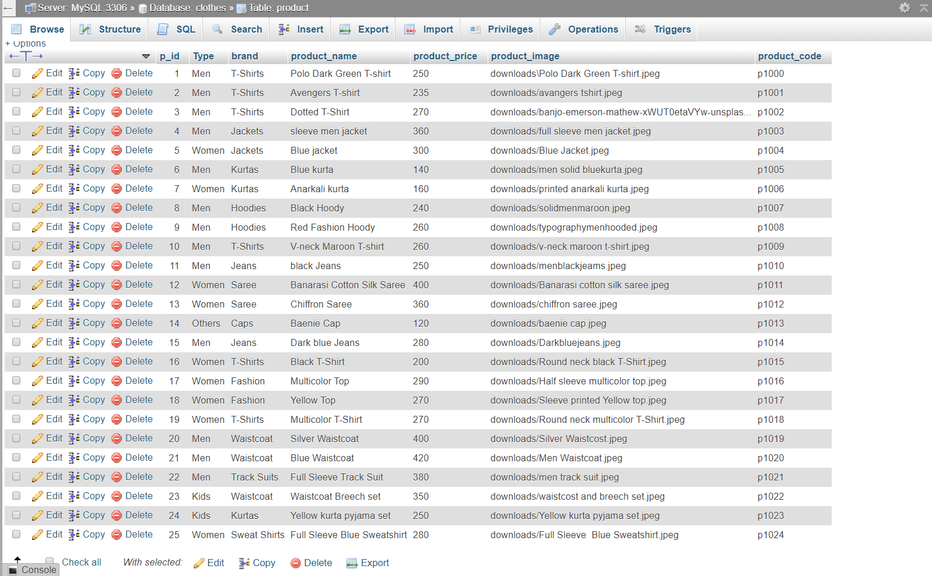

Fig 4.5- Product table Structure

Online Cloth Store Software Design

### 4.3.4 Cart Table Structure

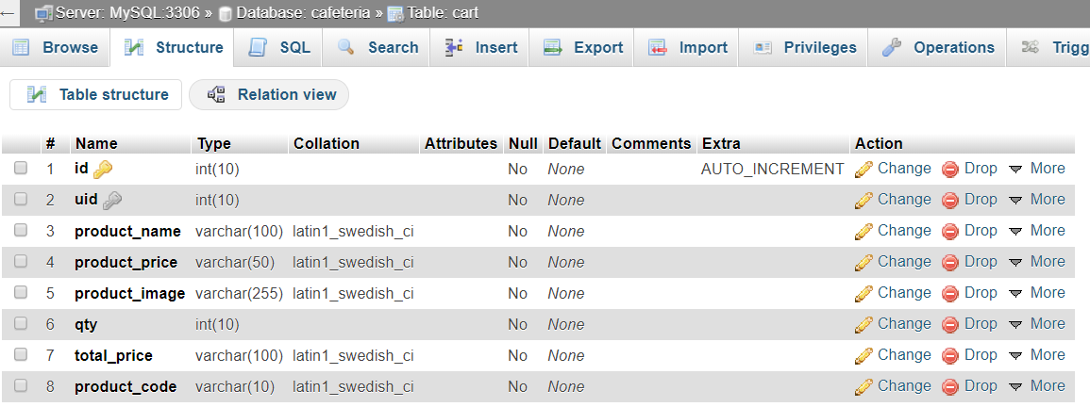

Fig 4.6- Cart Table Structure

### 4.3.5 Orders Table Structure

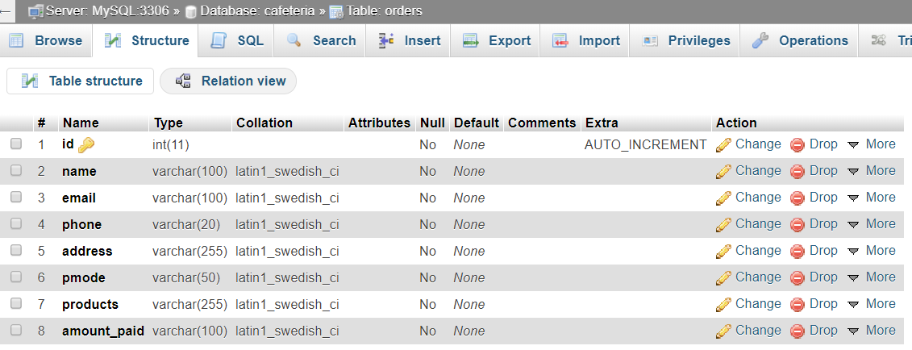

Fig 4.7- Order Table Structure

**Chapter 5**

# **Implementation**

## 5.1 Storing the files in Main Directory

First of all, We have to store all the files of our project in the htdocs folder of the wamp server so that wamp server can easily fetch the files on a localhost otherwise the localhost will not be able to detect the files. Files include images, php files, html files, css files, bootstrap files etc.

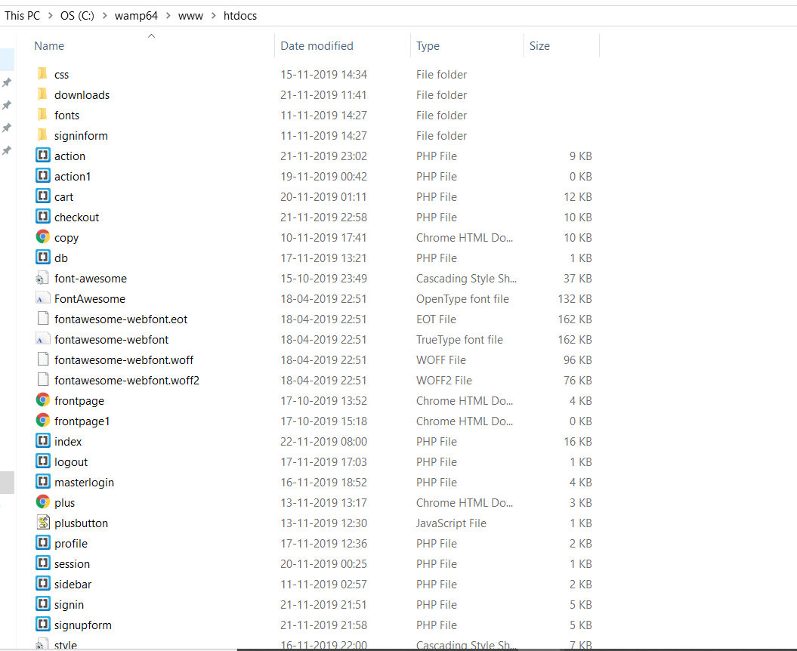

Fig 5.1 – Storing the files in main directory

## 

Online Cloth Store Implementation

## 5.2 Login Page

To design login page we used html and css for frontend and PHP for backend. Here are the layout and code for login.php through this login page any user can login.

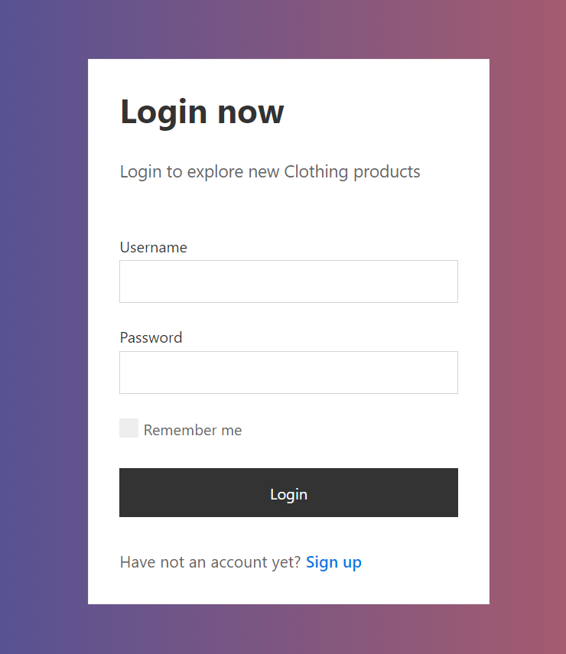

Fig 5.2 – login Page

Online Cloth Store Implementation

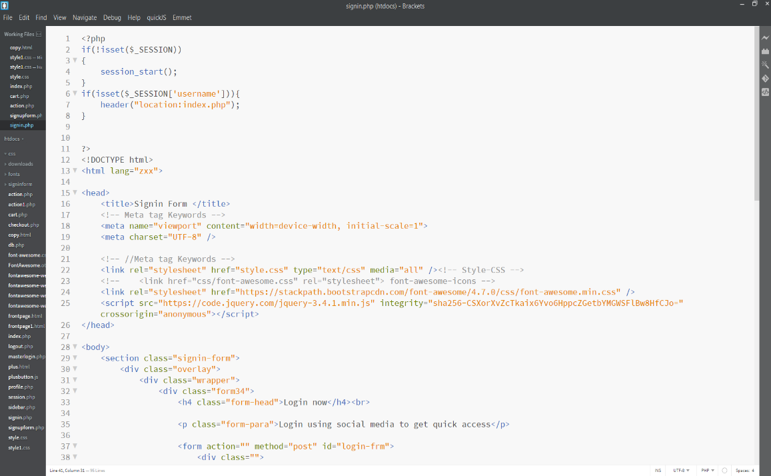

Fig 5.3 – Coding of login Page

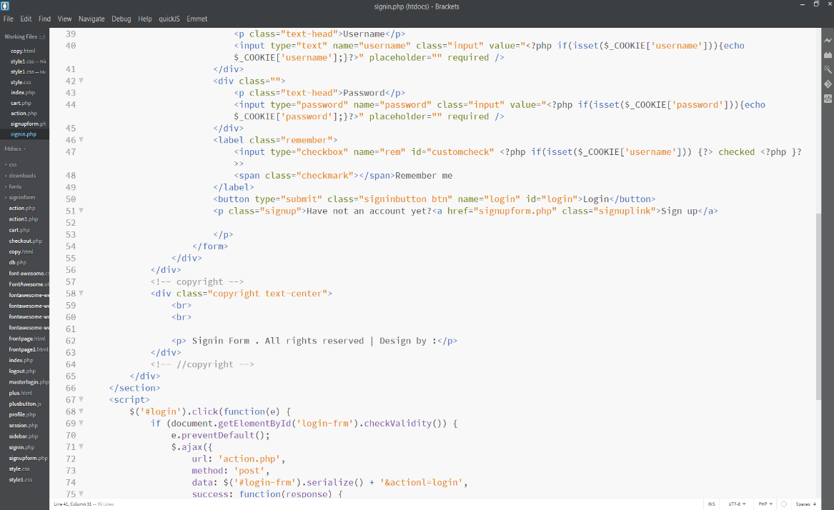

Fig 5.4 – Coding of login Page

Online Cloth Store Implementation

## 5.3 Signup Page

To design Signup page we used html and css for frontend and PHP for backend. Here are the layout and code for signup.php through this login page any user can signup.

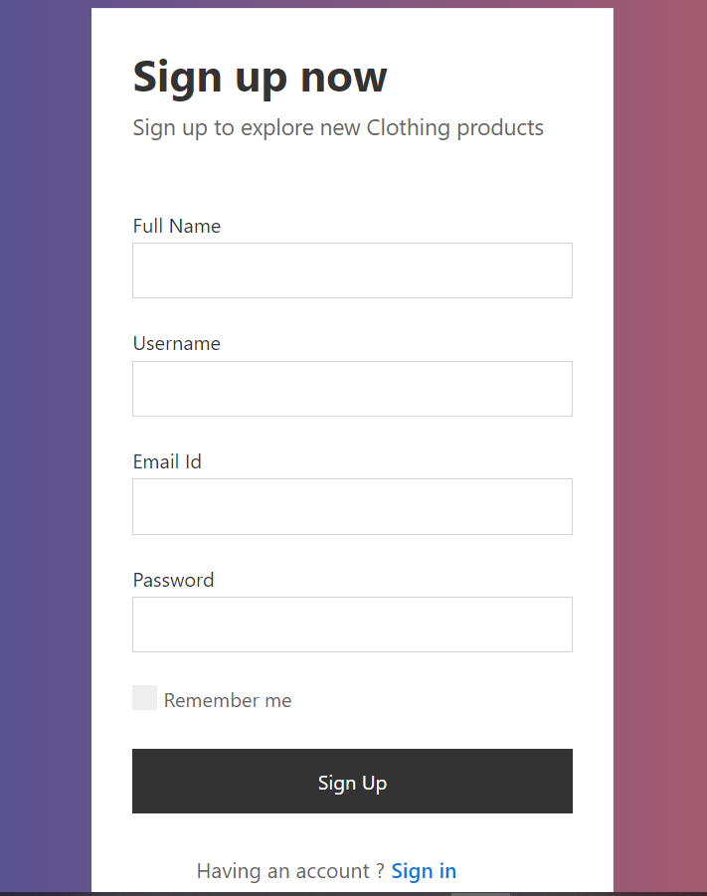

Fig 5.3 – Signup Page

Online Cloth Store Implementation

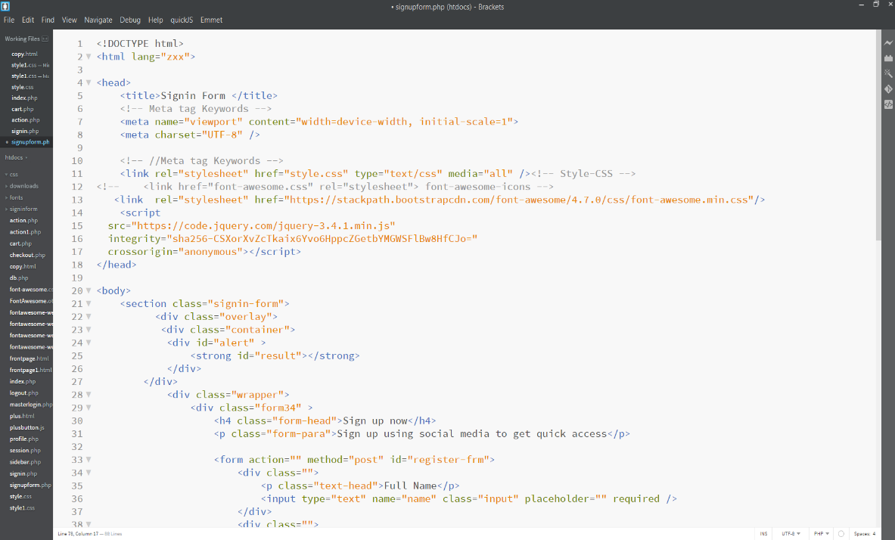

Fig 5.4 – Signup Page

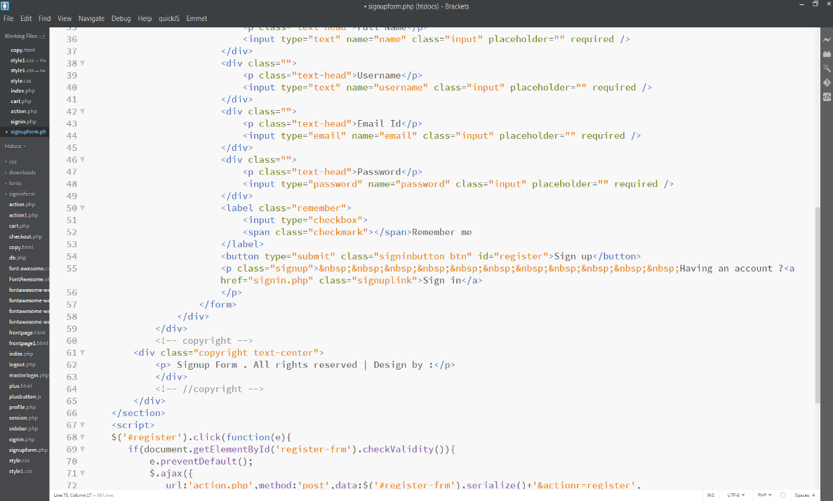

Fig 5.5 – Signup Page

Online Cloth Store Implementation

## 5.4 Main Page

It is a responsive page of our website which contains all the functionalities that a general cloth website should have in it.

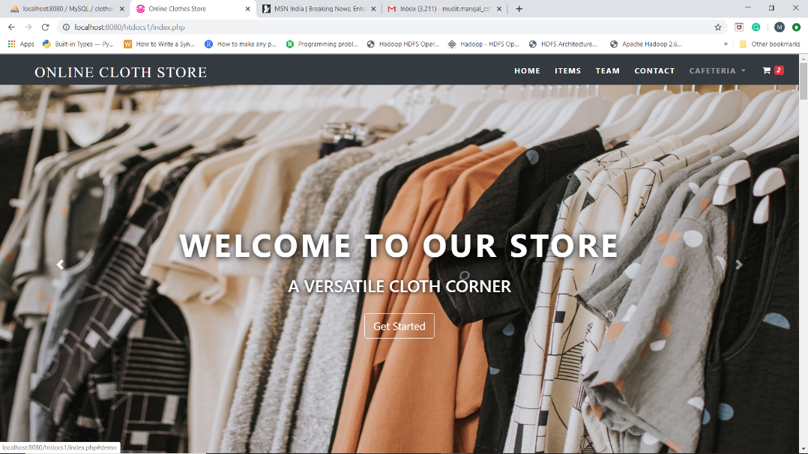

Fig 5.5 – Main Page

Online Cloth Store Implementation

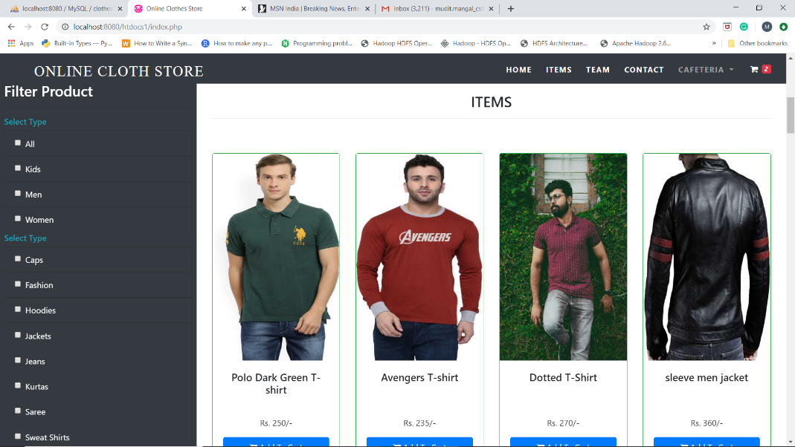

Fig 5.6 – Main Page

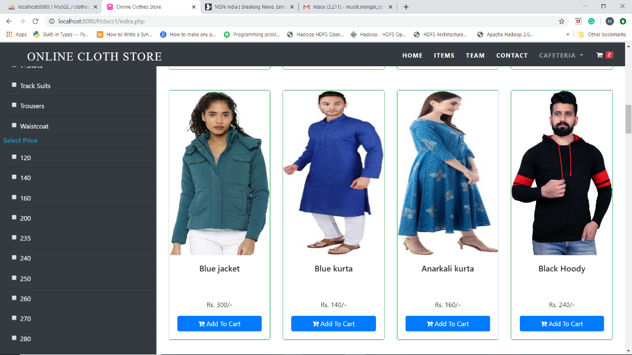

Fig 5.7 – Main Page

Online Cloth Store Implementation

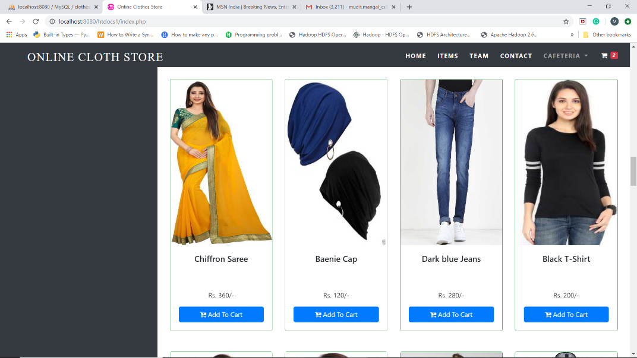

Fig 5.7– Main Page

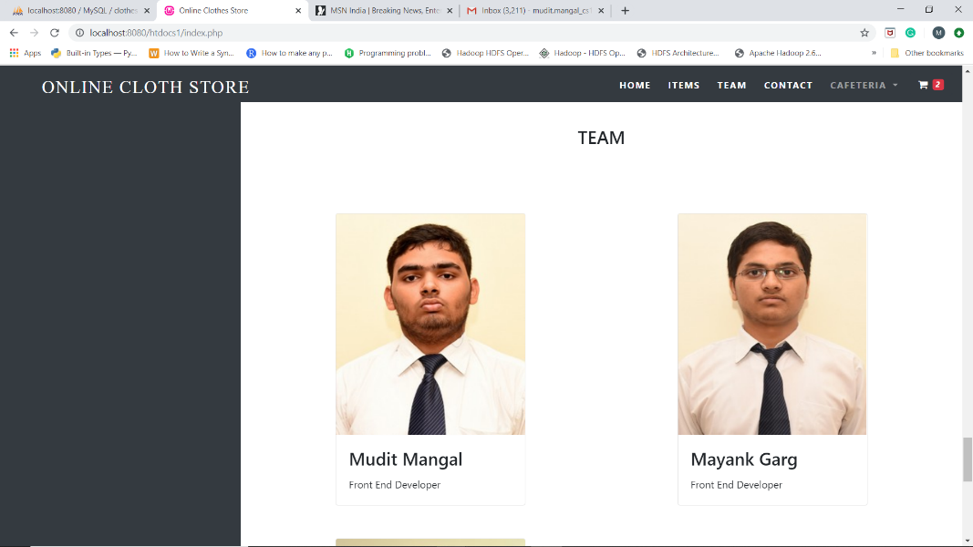

Fig 5.8– Our Team

Online Cloth Store Implementation

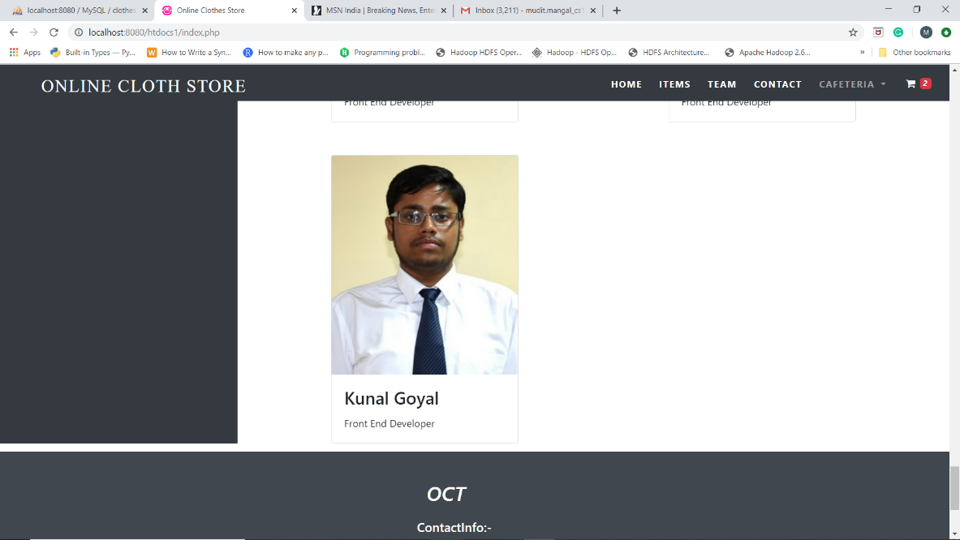

Fig 5.9– Our Team

## 5.5 Checkout Page

In this page, the items which has been selected by the respective user will be shown the cart.

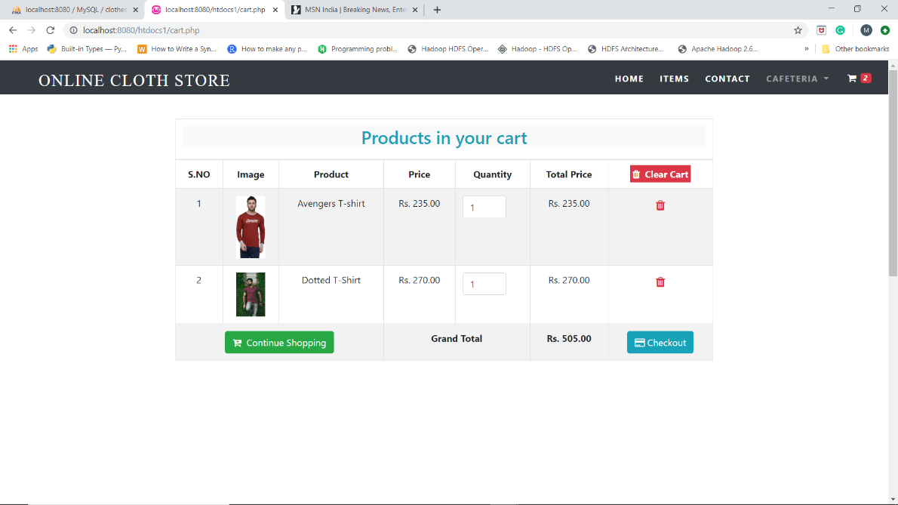

Fig 5.10– Checkout Page

Online Cloth Store Implementation

## 5.6 Enter details Page

The user will have to enter the personal details and Table Number to proceed further.

This data will get stored in cart table and will be displayed in greeting page.

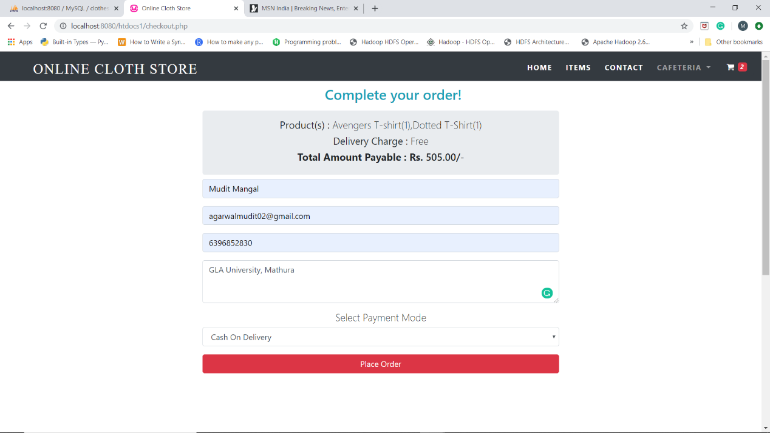

Fig 5.10- Place Order Page

Online Cloth Store Implementation

5.7 Greeting Page

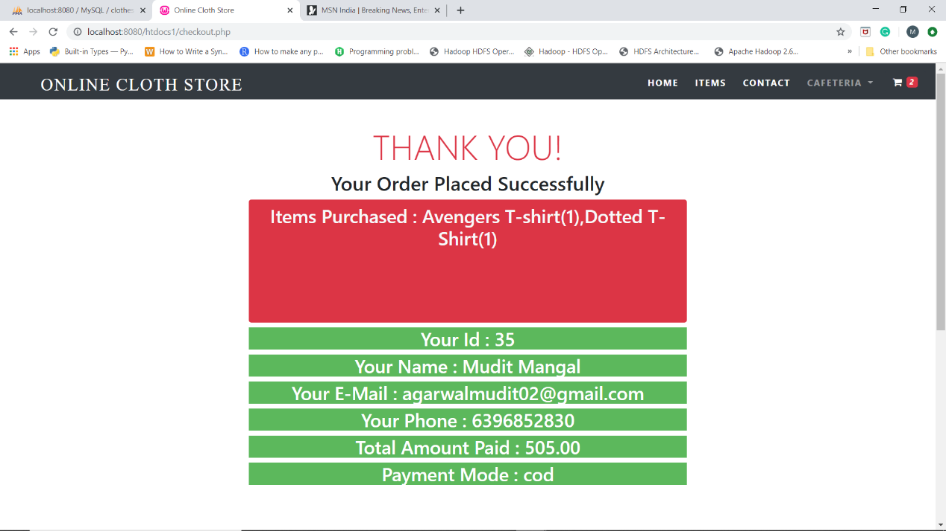

Fig 5.11-Greeting Page

**CHAPTER 6**

# **Validation**

## 6.1 Signup Page Validation

<script>

$('#register').click(function(e){

if(document.getElementById('register-frm').checkValidity()){

e.preventDefault();

$.ajax({

url:'action.php',method:'post',data:$('#register-frm').serialize()+'&actionr=register',

success:function(response){

alert(response);

// $("#alert").show();

// $('#result').html(response);

//

}

});

}

return true;

});

</script>

Online Cloth Store Validation

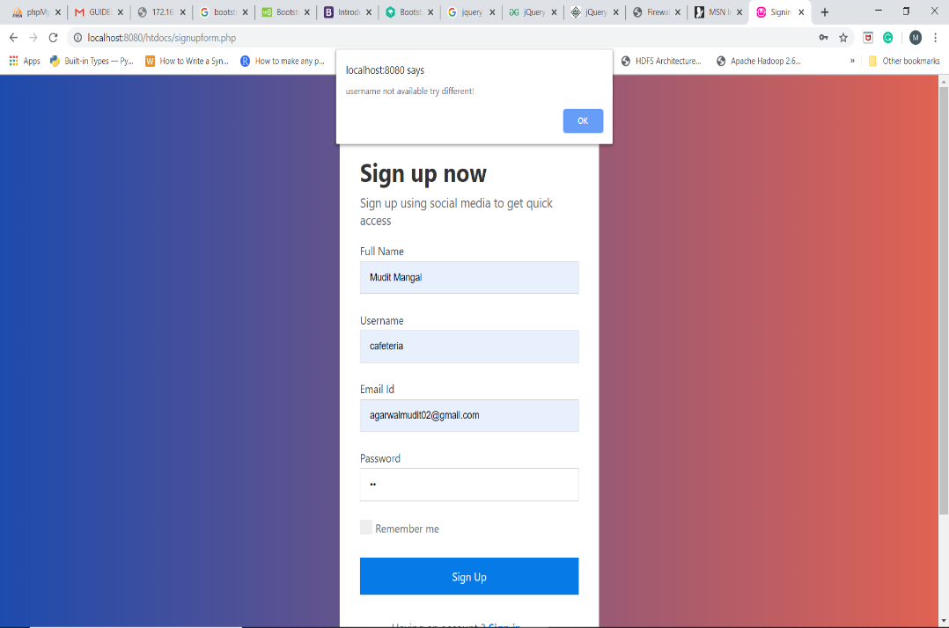

Fig 6.1- Username error message

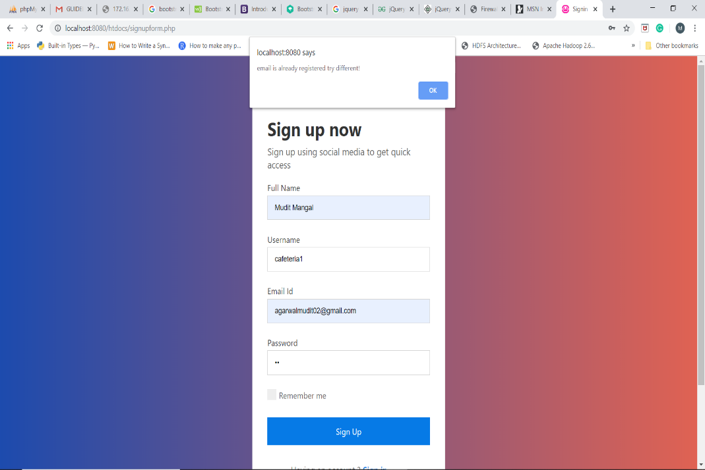

Fig 6.2- Email error message

Online Cloth Store Validation

6.2 Sign in Page Validation

<script>

$('#login').click(function(e) {

if (document.getElementById('login-frm').checkValidity()) {

e.preventDefault();

$.ajax({

url: 'action.php',

method: 'post',

data: $('#login-frm').serialize() + '&actionl=login',

success: function(response) {

if (response === "ok") {

window.location = 'index.php';

} else {

alert(response);

$("#alert").show();

$('#result').html(response);

}

}

});

}

return true;

});

</script>

Online Cloth Store Validation

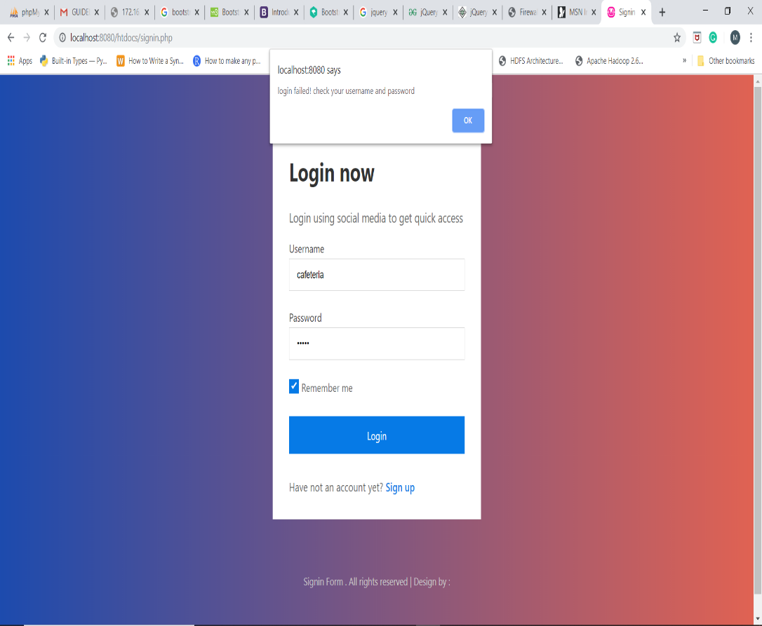

Fig 6.2- Login failed message

**CHAPTER 7**

# **Conclusion**

After the completion of project, customer can view the overall menu of our store but cannot order any item without registration. New customer can create a new account by going on sign up page. After registration, he can login and now can add any item in any quantity in the shopping cart. He can also apply different filters like price, category of cloth items etc. Quantity of items can be increased or decreased in the final cart page. Even he can delete any item or can clear overall cart items in one go by clicking the option clear cart. He can place the order only through cash on delivery mode. After placing the order, he can view the summary with an order id which is the table number of that particular customer.

**CHAPTER 8**

# **Future Scope**

This project is not fully completed yet. Online Cloth Store has more than this. If we continue this project in future then we can add following functionalities in it.

1. Admin Panel which can update the items like changing the price, quantity etc., make any item unavailable if not present, can see the order of customers.
2. Payment Gateway which will enable the people to pay the amount through debit cards, credit cards or net banking etc.
3. Discount coupons can be generated for the customers so that a greater number of customers can visit and order items on our website.

**CHAPTER 9**

# **References/Bibliography**

This project is the output of work of our team member and guidance of our mentor. But there are some websites which helped us a lot. They are:

1. <https://www.youtube.com/watch?v=5YgscpAC0gE>
2. <https://www.youtube.com/watch?v=cRoBoztHXr0>
3. <https://www.w3schools.com/bootstrap4/>
4. <https://www.w3schools.com/html/>
5. <https://www.w3schools.com/css/>
6. <https://www.w3schools.com/js/>
7. <https://www.w3schools.com/jquery>